1. **What is the difference between a function and a method in Python?**

A function is a block of code that performs a specific task.

A method is a function that is associated with an object.

1. **Explain the concept of function arguments and parameters in Python.**

Parameters are the names used in a function definition to specify what kind of arguments the function can accept. Arguments are the actual values you pass into a function when calling it.

1. **What are the different ways to define and call a function in Python?**

we can standardize a function by using **def.**

we can use anonymous functions by using **lamda**

we can use positional arguments like calling functions.

1. **What is the purpose of the `return` statement in a Python function?**

It gives back the result of the function for further use:

1. **What are iterators in Python and how do they differ from iterables?**

An **iterable** is any object that **can be looped over** (used in a for loop).

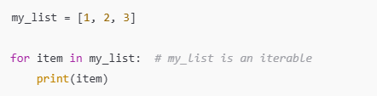

1. **Explain the concept of generators in Python and how they are defined.**

A **generator** is a special type of function that **produces values on the fly** using the yield keyword instead of return.

* Generators **do not store** all values in memory.
* They are **lazy**, meaning they only compute values when requested.

1. **What are the advantages of using generators over regular functions?**

Generators yield items one at a time instead of storing the entire sequence in memory like lists or regular functions that return collections.

1. **What is a lambda function in Python and when is it typically used?**

A **lambda function** in Python is a **small anonymous function** defined using the lambda keyword instead of def. It can have **any number of arguments** but only **one expression**, which is implicitly returned.

1. **Explain the purpose and usage of the `map()` function in Python**

The map() function is a **built-in Python function** used to **apply a function to every item in an iterable** (like a list, tuple, etc.) and return a **map object** (which is an iterator).

1. **What is the difference between `map()`, `reduce()`, and `filter()` functions in Python?**

| **Function** | **Purpose** | **Output** |
| --- | --- | --- |
| map() | Transforms each item in an iterable | New iterable with transformed items |
| filter() | Selects items based on a condition | New iterable with filtered items |
| reduce() | Aggregates items to a single result | A single cumulative value |

1. **Using pen & Paper write the internal mechanism for sum operation using  reduce function on this given list:[47,11,42,13];**

**Image given below**

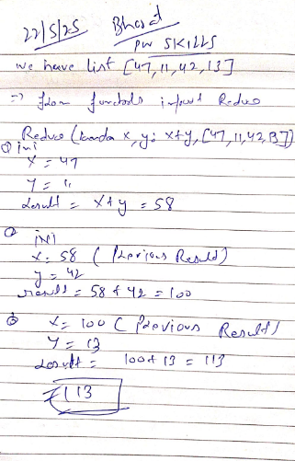

* 1. Write a Python function that takes a list of numbers as input and returns the sum of all even numbers in the list.

* 1. Create a Python function that accepts a string and returns the reverse of that string.

* 1. Implement a Python function that takes a list of integers and returns a new list containing the squares of each number. 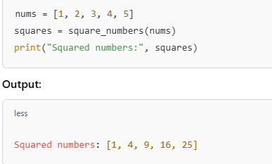
  2. Write a Python function that checks if a given number is prime or not from 1 to 200. 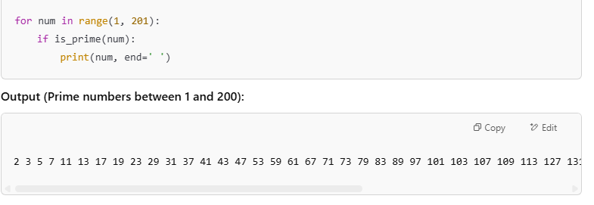
  3. Create an iterator class in Python that generates the Fibonacci sequence up to a specified number of terms. A screenshot of a computer program

     AI-generated content may be incorrect.
  4. Write a generator function in Python that yields the powers of 2 up to a given exponent.

* 1. Implement a generator function that reads a file line by line and yields each line as a string.

* 1. Use a lambda function in Python to sort a list of tuples based on the second element of each tuple. A screenshot of a computer

     AI-generated content may be incorrect.
  2. Write a Python program that uses `map()` to convert a list of temperatures from Celsius to Fahrenheit. 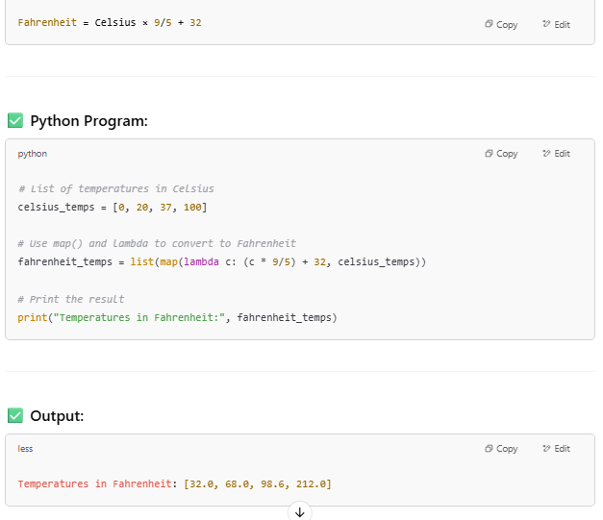
  3. Create a Python program that uses `filter()` to remove all the vowels from a given string.

* 1. Imagine an accounting routine used in a book shop. It works on a list with sublists, which look like this: Write a Python program, which returns a list with 2-tuples. Each tuple consists of the order number and the product of the price per item and the quantity. The product should be increased by 10,- € if the value of the order is smaller than 100,00 €. Write a Python program using lambda and map.

